

DEPARTMENT OF COMPUTER SCIENCE and ENGINEERING
Compiler Design
Lab Manual
TABLE OF CONTENTS

Sl.  No | Description of the item/title | Page No.
i. | Importance/Rationale behind the CD Lab | 1
ii. | General Laboratory Instructions | 2
iii. | Objectives & Outcomes | 3
iv. | Software / Hardware Requirements | 3
1. | Write a LEX Program to scan reserved word & Identifiers of C Language | 4
2. | Write a ‘C’ Program to implement for the Predictive Parser | 7
3. | Write a C program to generate three address code | 11
4. | Design and implement an SLR(1) Bottom up Parser | 15
5. | Design a LALR bottom up parser for the given language | 22
Additional Tasks / Programs
1 | Design and implement Recursive Descent Parser | 28
2 | Design and implement a Lexical Analyzer. | 30
3 | Write a LEX Program to check vowel or consonant | 32
4 | Write a LEX Program to check Operator | 33

GENERAL LABORATORY INSTRUCTIONS

  - Students are advised to come to the laboratory at least 5 minutes before (to the starting time), those who come after 5 minutes will not be allowed into the lab.
  - Plan your task properly much before to the commencement, come prepared to the lab with the synopsis / program / experiment details.
  - Student should enter into the laboratory with:
    - Laboratory observation notes with all the details (Problem statement, Aim, Algorithm, Procedure, Program, Expected Output, etc.,) filled in for the lab session.
    - Laboratory Record updated up to the last session experiments and other utensils (if any) needed in the lab.
    - Proper Dress code and Identity card.
  - Sign in the laboratory login register, write the TIME-IN, and occupy the computer system allotted to you by the faculty.
  - Execute your task in the laboratory, and record the results / output in the lab observation note book, and get certified by the concerned faculty.
  - All the students should be polite and cooperative with the laboratory staff, must maintain the discipline and decency in the laboratory.
  - Computer labs are established with sophisticated and high end branded systems, which should be utilized properly.
  - Students / Faculty must keep their mobile phones in SWITCHED OFF mode during the lab sessions. Misuse of the equipment, misbehaviors with the staff and systems etc., will attract severe punishment.
  - Students must take the permission of the faculty in case of any urgency to go out, if anybody found loitering outside the lab / class without permission during working hours will be treated seriously and punished appropriately.
  - Students should LOG OFF/ SHUT DOWN the computer system before he/she leaves the lab after completing the task (experiment) in all aspects. He/she must ensure the system / seat is kept properly.

Importance of Compiler Design Lab
Every software has to be translated to its equivalent machine instruction form so that it will be executed by the underlying machine. There are many different types of system software’s that help during this translation process. Compiler is one such an important System Software that converts High level language programs to its equivalent machine (low level) language. It is impossible to learn and use machine language in software development for the users. Therefore we use high level computer languages to write programs and then convert such programs into machine understandable form with the help of mediator software’s such as compilers, interpreters, assemblers etc. Thus compiler bridges the gap between the user and the machine, i.e., computer.

It's a very complicated piece of software which took 18 man years to build first compiler .To build this software we must understand the principles, tools, and techniques used in its working. The compiler goes through the following sequence of steps called phases of a compiler.

- Lexical Analysis
- Syntax Analysis
- Semantic Analysis
- Intermediate Code Generation
- Code Optimization
- Code Generation.

In performing its role, compiler also uses the services of two essential components namely, Symbol Table and Error Handler

The objective of the Compiler Design Laboratory is to understand and implement the principles, techniques, and also available tools used in compiler construction process. This will enable the students to work in the development phase of new computer languages in industry.

OBJECTIVES AND OUTCOMES

OBJECTIVES:
- To understand the various phases in the design of a compiler.
- To understand the design of top-down and bottom-up parsers.
- To understand syntax directed translation schemes.
- To introduce lex and yacc tools.
OUTCOMES:

- Ability to design, develop, and implement a compiler for any language.
- Able to use lex and yacc tools for developing a scanner and a parser.
- Able to design and implement LL and LR parsers.

RECOMMENDED SYSTEM / SOFTWARE REQUIREMENTS:

- Intel based desktop PC with minimum of 166MHz or faster processor with at least 64 MB RAM and 100 MB free disk space.

- C Compiler and Lex or Flex and YACC tools (Unix/Linux utilities)

USEFUL TEXT BOOKS / REFERECES / WEBSITES :

  - Modern compiler implementation in C, Andrew w.Appel, Revised Edn, Cambridge University Press
  - Principles of Compiler Design. – A.V Aho, J.D Ullman ; Pearson Education.
  - lex&yacc , -John R Levine, Tony Mason, Doug Brown; O’reilly.
  - Compiler Construction,- LOUDEN, Thomson.
  - Engineering a compiler – Cooper& Linda, Elsevier
  - Modern Compiler Design – Dick Grune,Henry E.Bal, Cariel TH Jacobs, Wiley Dreatech
- Problem Statement: Implement the lexical analyzer using JLex, flex or other lexical Analyzer generating tools.

AIM: Write a LEX Program to scan reserved word & Identifiers of C Language

ALGORITHM / PROCEDURE:
Input : LEX specification files for the token
Output : Produces the source code for the Lexical Analyzer with the name lex.yy.c and displays reserved word & Identifiers from an input file.
  - Start
  - Open a file in text editor
  - Create a Lex specifications file to accept keywords, identifiers, constants, operators and relational operators in the following format.
    - %{
Definition of constant /header files
%}
    - Regular Expressions
%%
Transition rules
%%
    - Auxiliary Procedure (main( ) function)
  - Save file with .l extension e.g. mylex.l
  - Call lex tool on the terminal e.g. [root@localhost]# lex mylex.l. This lex tool will convert
“.l” file into “.c” language code file i.e., lex.yy.c
  - Compile the file lex.yy.c using C / C++ compiler. e.g. gcc lex.yy.c. After compilation the file lex.yy.c, the output file is in a.out
  - Run the file a.out giving an input(text/file) e.g. ./a.out.
  - Upon processing, the sequence of tokens will be displayed as output.
  - Stop

DESCRIPTION:

C Identifiers
C identifiers represent the name in the C program, for example, variables, functions, arrays, structures, unions, labels, etc. An identifier can be composed of letters such as uppercase, lowercase letters, underscore, digits, but the starting letter should be either an alphabet or an underscore. If the identifier is not used in the external linkage, then it is called as an internal identifier. If the identifier is used in the external linkage, then it is called as an external identifier.
We can say that an identifier is a collection of alphanumeric characters that begins either with an alphabetical character or an underscore, which are used to represent various programming elements such as variables, functions, arrays, structures, unions, labels, etc. There are 52 alphabetical characters (uppercase and lowercase), underscore character, and ten numerical digits (0-9) that represent the identifiers. There is a total of 63 alphanumerical characters that represent the identifiers.

Rules for constructing C identifiers
- The first character of an identifier should be either an alphabet or an underscore, and then it can be followed by any of the character, digit, or underscore.
- It should not begin with any numerical digit.
- In identifiers, both uppercase and lowercase letters are distinct. Therefore, we can say that identifiers are case sensitive.
- Commas or blank spaces cannot be specified within an identifier.
- Keywords cannot be represented as an identifier.
- The length of the identifiers should not be more than 31 characters.
- Identifiers should be written in such a way that it is meaningful, short, and easy to read.

RESERVED WORD: In C, we have 32 keywords, which have their predefined meaning and cannot be used as a variable name. These words are also known as “reserved words”. It is good practice to avoid using these keywords as variable name. These are –
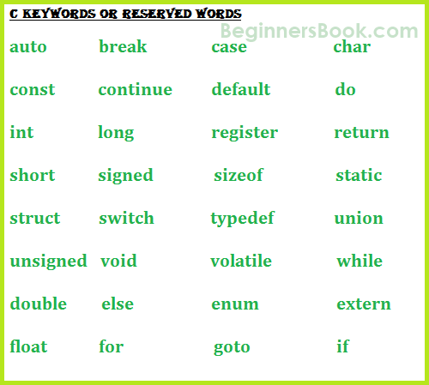

Basics usage of these keywords –
if, else, switch, case, default – Used for decision control programming structure.
break – Used with any loop OR switch case.
int, float, char, double, long – These are the data types and used during variable declaration.
for, while, do – types of loop structures in C.
void – One of the return type.
goto – Used for redirecting the flow of execution.
auto, signed, const, extern, register, unsigned – defines a variable.
return – This keyword is used for returning a value.
continue – It is generally used with for, while and dowhile loops, when compiler encounters this statement it performs the next iteration of the loop, skipping rest of the statements of current iteration.
enum – Set of constants.
sizeof – It is used to know the size.
struct, typedef – Both of these keywords used in structures (Grouping of data types in a single record).
union – It is a collection of variables, which shares the same memory location and memory storage.

LEX SPECIFICATION PROGRAM / SOURCE CODE (identifier.l) :

// ********* LEX Tool program to scan Identifiers *****************//

%{
#include<stdio.h>
%}

letter [a-zA-Z_]
digit [0-9]
special [;:./\,&'$#^@~?]

%%

(auto|break|case|char|const|continue|default|do|double|else|enum|extern|float|for|goto|if|int|long|register|return|short|signed|sizeof|static|struct|switch|typedef|union|unsigned|void|volatile|while)* {printf("\n%s is not an Identifier\nReason: Cannot be a Keyword!",yytext);}

{letter}({letter}|{digit})* {printf("\n%s is an identifier",yytext);}

{digit}({letter}|{digit})* {printf("\n%s is not an identifier\nReason:Cannot start with a digit",yytext);}

({special}|{letter}|{digit})({special}|{letter}|{digit})* {printf("\n%s is not an identifier\nReason:Cannot contain a special charcter!",yytext);}

%%

int main()
{
yylex();
}
int yywrap()
{
return 0;
}

Output:

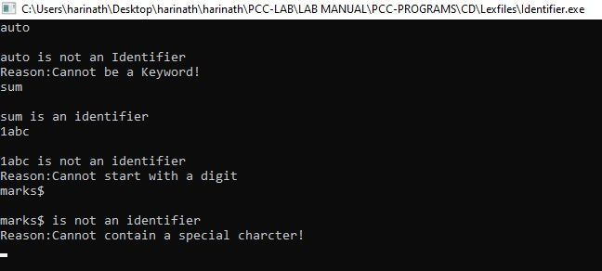

LEX SPECIFICATION PROGRAM / SOURCE CODE (reserveword.l) :

// ********* LEX Tool program to scan reserve word *****************//

%{
#include<stdio.h>
%}

letter[a-zA-Z_]

digit[0-9]

%%

(auto|break|case|char|const|continue|default|do|double|else|enum|extern|float|for|goto|if|int|long|register|return|short|signed|sizeof|static|struct|switch|typedef|union|unsigned|void|volatile|while)* {printf("\n%s is a keyword!",yytext);}

({letter}|{digit})({letter}|{digit})* {printf("\n%s is not a keyword",yytext);}

%%
int main()
{
yylex();
}
int yywrap()
{
return 0;
}
Output:

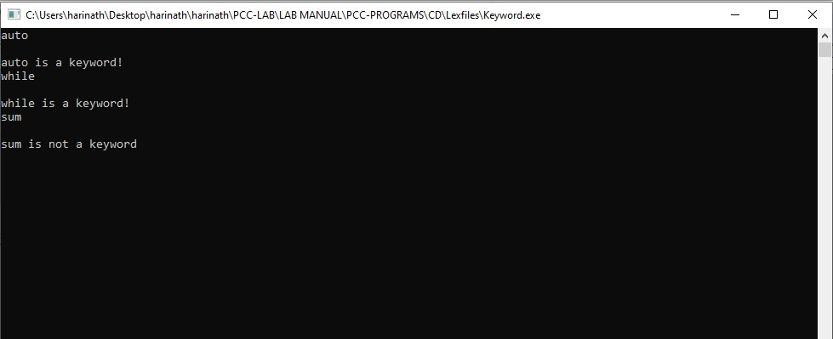

Viva Questions:
- List the different sections available in LEX compiler?
- What is an auxiliary definition?
- How can we define the translation rules?
- What is regular expression?
- What is finite automaton?
- What is Jlex?
- What is Flex?
- What is lexical analyzer generator?
- What is the input for LEX Compiler?
- What is the output of LEX compiler?

- Problem Statement : Design Predictive Parser for the following grammar
E→TA
A→+TA/Ꜫ
T→FB
B→*FB/Ꜫ
F→(E)/i
AIM: To write a ‘C’ Program to implement for the Predictive Parser (Non Recursive Descent parser) for the given grammar

Given the parse Table:
 | i | + | * | ( | ) | $
E | E→TA |  |  | E→TA
A |  | A →+TA |  |  | A→Ꜫ | A→Ꜫ
T | T→FB |  |  | T→FB
B |  | B→Ꜫ | B→*FB |  | B→Ꜫ | B→Ꜫ
F | F→ i |  |  | F→(E)

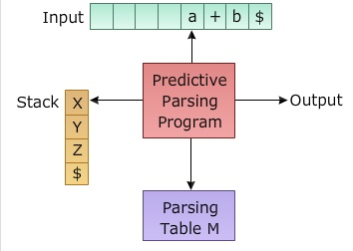

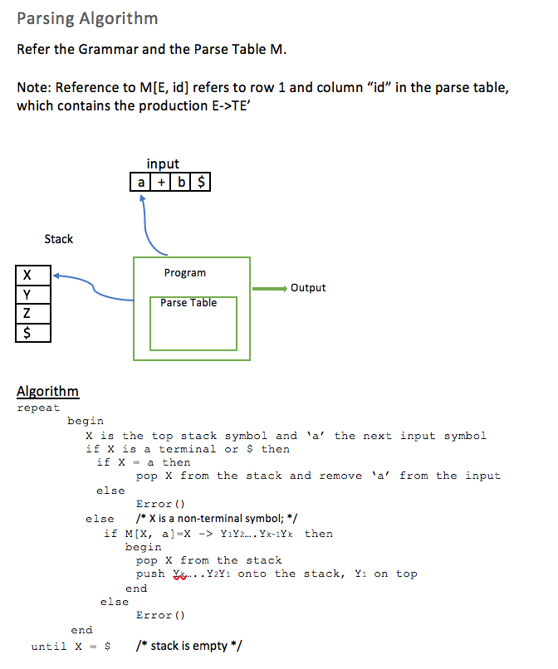

SOURCE CODE :

// ***IMPLEMENTATION OF PREDICTIVE PARSING *****//
#include<stdio.h>
#include<stdlib.h>
#include<string.h>
void push(char);
void pop();
char input[10];
char stk[20];
int top=-1;
int ip=0;
void push(char c)
{
if(top>=20)
{
printf("stack overflow");
}
else
{
stk[++top]=c;
}
}

void pop()
{
if(top==-1)
{
printf("stack underflow");
}
else
top--;
}
void display()
{
int i;
for(i=0;i<=top;i++)
printf("%c",stk[i]);
}
void inputdisplay()
{
int i;
i=ip;
while(input[i]!='\0')
printf("%c",input[i++]);
}

void main()
{
int flag=0;
clrscr();
printf("\nEnter the input to be parsed with the delimiter $");
scanf("%s",input);
push('$');
push('E');
printf("STACK INPUTDATA");
while(1)
{
printf("\n");
display();
printf(" ------------------------------------- ");
inputdisplay();
if(stk[top]=='$'&&input[ip]=='$')
{
flag=1;
printf("\nSuccessful parser");
break;
}
else if(stk[top]==input[ip])
{
ip++;
pop();
}
else if(stk[top]=='E')
{
if(input[ip]=='i'|| '(')
{
pop();
push('A');
push('T');
}
else
break;

}
else if(stk[top]=='A')
{
if(input[ip]=='+')
{
pop();
push('A');
push('T');
push('+');
}
else if(input[ip]==')'||'$')
{
pop();
}
else
break;
}
else if(stk[top]=='T')
{
if(input[ip]=='i'||'(')
{
pop();
push('B');
push('F');
}
else
break;
}
else if(stk[top]=='B')
{
if(input[ip]=='*')
{
pop();
push('B');
push('F');
push('*');
}
else if(input[ip]=='+'||')'||'$')
{
pop();
}
else
break;
}
else if(stk[top]=='F')
{
if(input[ip]=='i')
{
pop();
push('i');
}
else if(input[ip]=='(')
{
pop();
push(')');
push('E');
push('(');
}
else
break;
}
else
break;
}
if(flag==0)
printf("\nIt is an invalid input");
getch();
}

INPUT: i+i$
OUTPUT:
-----------------------
Stack Input
-----------------------
$E i+i$
$AT i+i$
$ABF i+i$
$ABi i+i$
$AB +i$
$A +i$
$AT+ +i$
$AT i$
$ABF i$
$ABi i$
$A $
$ $
SUCCESSFULLY PARSED

Viva Questions:
- What is top-down parsing?
- What are the disadvantages of brute force method?
- What is context free grammar?
- What is parse tree?
- What is ambiguous grammar?
- What are the derivation methods to generate a string for the given grammar?
- What is the output of parse tree?
- What is Predictive parser?
- How many types of analysis can we do using Parser?
- What is Recursive Decent Parser?

- Problem Statement: Write a C program to generate three address code.

AIM: To write a ‘C’ Program to generate three address code

DESCRIPTION: Three address code is a type of intermediate code which is easy to generate and can be easily converted to machine code.It makes use of at most three addresses and one operator to represent an expression and the value computed at each instruction is stored in temporary variable generated by compiler. The compiler decides the order of operation given by three address code.

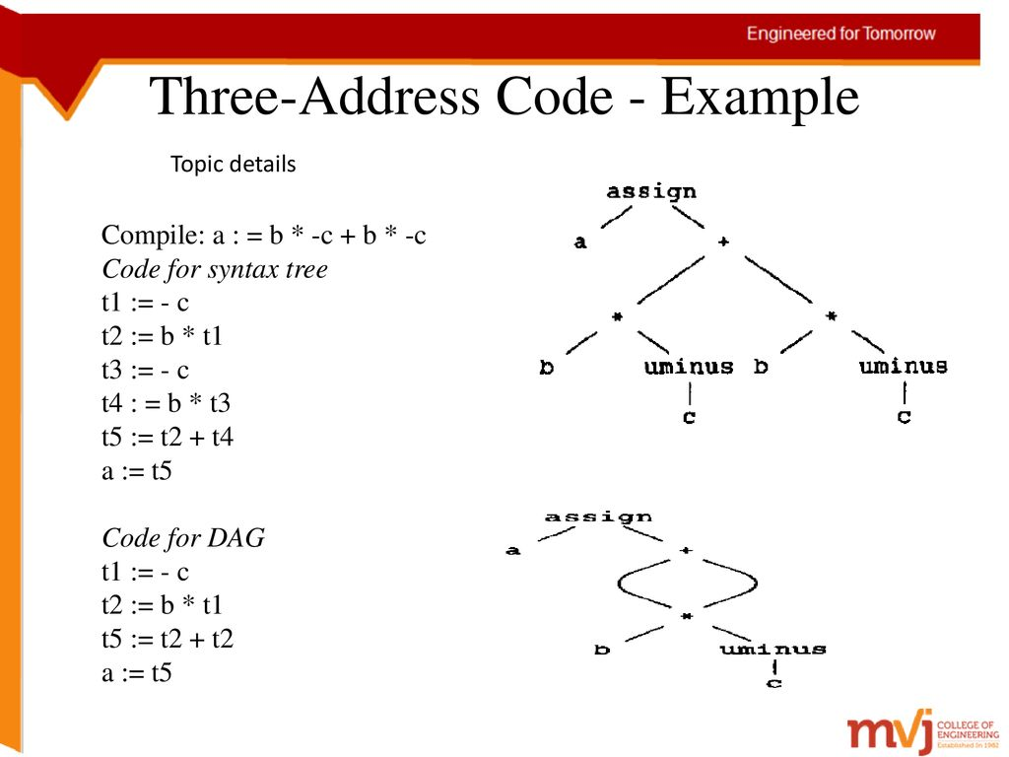

SOURCE CODE :

#include<stdio.h>
#include<string.h>
void pm();
void plus();
void div();
int i,ch,j,l,addr=100;
char ex[10], exp[10] ,exp1[10],exp2[10],id1[5],op[5],id2[5];
void main()
{
clrscr();
while(1)
{
printf("\n1.assignment\n2.arithmetic\n3.relational\n4.Exit\nEnter the choice:");
scanf("%d",&ch);
switch(ch)
{
case 1:
printf("\nEnter the expression with assignment operator:");
scanf("%s",exp);
l=strlen(exp);
exp2[0]='\0';
i=0;
while(exp[i]!='=')
{
i++;
}
strncat(exp2,exp,i);
strrev(exp);
exp1[0]='\0';
strncat(exp1,exp,l-(i+1));
strrev(exp1);
printf("Three address code:\ntemp=%s\n%s=temp\n",exp1,exp2);
break;
case 2:
printf("\nEnter the expression with arithmetic operator:");
scanf("%s",ex);
strcpy(exp,ex);
l=strlen(exp);
exp1[0]='\0';
for(i=0;i<l;i++)
{
if(exp[i]=='+'||exp[i]=='-')
{
if(exp[i+2]=='/'||exp[i+2]=='*')
{
pm();
break;
}
else
{
plus();
break;
}
}
else if(exp[i]=='/'||exp[i]=='*')
{
div();
break;
}
}
break;
case 3:
printf("Enter the expression with relational operator");
scanf("%s%s%s",&id1,&op,&id2);
if(((strcmp(op,"<")==0)||(strcmp(op,">")==0)||(strcmp(op,"<=")==0)||(strcmp(op,">=")==0)||(strcmp(op,"==")==0)||(strcmp(op,"!=")==0))==0)
printf("Expression is error");
else
{
printf("\n%d\tif %s%s%s goto %d",addr,id1,op,id2,addr+3);
addr++;
printf("\n%d\t T:=0",addr);
addr++;
printf("\n%d\t goto %d",addr,addr+2);
addr++;
printf("\n%d\t T:=1",addr);
}
break;
case 4:
exit(0);
}
}
}
void pm()
{
strrev(exp);
j=l-i-1;
strncat(exp1,exp,j);
strrev(exp1);
printf("Three address code:\ntemp=%s\ntemp1=%c%ctemp\n",exp1,exp[j+1],exp[j]);
}
void div()
{
strncat(exp1,exp,i+2);
printf("Three address code:\ntemp=%s\ntemp1=temp%c%c\n",exp1,exp[i+2],exp[i+3]);
}
void plus()
{
strncat(exp1,exp,i+2);
printf("Three address code:\ntemp=%s\ntemp1=temp%c%c\n",exp1,exp[i+2],exp[i+3]);
}

OUTPUT:
1. assignment
2. arithmetic
3. relational
4. Exit
Enter the choice:1
Enter the expression with assignment operator:
a=b
Three address code:
temp=b
a=temp
1.assignment
2.arithmetic
3.relational
4.Exit
Enter the choice:2
Enter the expression with arithmetic operator:
a+b-c
Three address code:
temp=a+b
temp1=temp-c
1.assignment
2.arithmetic
3.relational
4.Exit
Enter the choice:2
Enter the expression with arithmetic operator:
a-b/c
Three address code:
temp=b/c
temp1=a-temp
1.assignment
2.arithmetic
3.relational
4.Exit
Enter the choice:2
Enter the expression with arithmetic operator:
a*b-c
Three address code:
temp=a*b
temp1=temp-c
1.assignment
2.arithmetic
3.relational
4.Exit
Enter the choice:2
Enter the expression with arithmetic operator:
a/b*c
Three address code:
temp=a/b
temp1=temp*c
temp=a/b
temp1=temp*c
1.assignment
2.arithmetic
3.relational
4.Exit
Enter the choice:3
Enter the expression with relational operator
a<=b
Three address code:
100 if a<=b goto 103
101 T:=0
102 goto 104
103 T:=1
1.assignment
2.arithmetic
3.relational
4.Exit
Enter the choice:4

Viva Questions:

  - Write the forms of Intermediate Code?
  - How Three Address Code (3AC) can be represented?
  - Write 3AC for Expressions?
  - Example for Triples?
  - Example for Quadruples?
  - Example for Indirect Triples?

- Problem Statement: Design a SLR(1) Bottom Up Parser

Aim: To Design and implement an SLR (1) Bottom up Parser

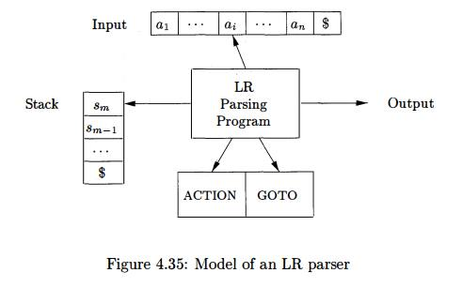

ALGORITHM:
Step1: Start
Step2: Initially the parser has s0 on the stack where s0 is the initial state and w$ is in buffer
Step3: Set ip point to the first symbol of w$
Step4: repeat forever, begin
Step5: Let S be the state on top of the stack and a symbol pointed to by ip
Step6: if action [S, a] =shift S then begin
Push S1 on to the top of the stack
Advance ip to next input symbol
Step7:else if action [S, a], reduce A→B then begin Pop 2* |B| symbols of the stack
Let S1 be the state now on the top of the stack
Step8: Output the production A→B
End
Step9: else if action [S, a]=accepted, then return else error()
End
Step10: Stop

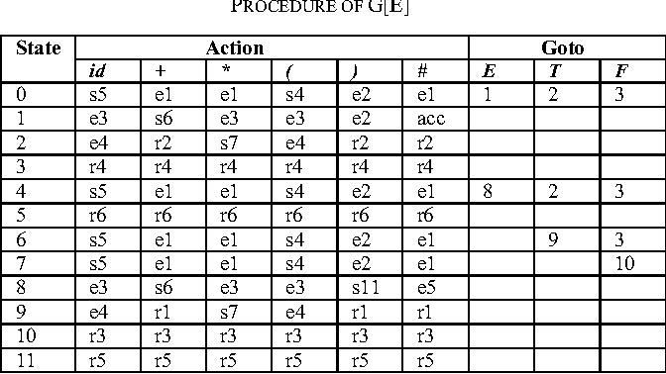
Source Code : SLR(1) Parser

#include<stdio.h>
#include<stdlib.h>
void push(char);
void pop();
char input[10];
char stk[30];
void error();
int top=-1;
int ip=0;
void push(char c)
{
if(top>=30)
{
printf("stack overflow");
}
else
{
stk[++top]=c;
}
}
void pop()
{
if(top==-1)
{
printf("stack underflow");
}
else
top--;
}
void display()
{
int i;
for(i=0;i<=top;i++)
printf("%c",stk[i]);
}
void inputdisplay()
{
int i;
i=ip;
while(input[i]!='\0')
printf("%c",input[i++]);
}
void main()
{
int flag=0;
clrscr();
printf("\nEnter the input to be parsed with the delimiter $");
scanf("%s",input);
push('0');
printf("STACK INPUT");
while(1)
{
printf("\n");
display();
printf(" --------------------------- ");
inputdisplay();
switch(stk[top])
{
case '0':
if(input[ip]=='i')
{
ip++;
push('i');
push('5');
}
else if(input[ip]=='(')
{
ip++;
push('(');
push('4');
}
else
error();
break;
case '1':
if(input[ip]=='+')
{
ip++;
push('+');
push('6');
}
else if(input[ip]=='$')
{
printf("successful parsed");
exit(1);
}
else
error();
break;
case '2':
if(input[ip]=='*')
{
ip++;
push('*');
push('7');
}
else if(input[ip]=='+'||')'||'$')
{
pop();
pop();
push('E');
if(stk[top-1]=='0')
push('1');
else if(stk[top-1]=='4')
push('8');
else
error();
}
else
error();
break;
case '3':
if(input[ip]=='+'||'*'||')'||'$')
{
pop();
pop();
push('T');
if(stk[top-1]=='0')
push('2');
else if(stk[top-1]=='4')
push('2');
else if(stk[top-1]=='6')
push('9');
else
error();
}
else
error();
break;
case '4':
if(input[ip]=='i')
{
ip++;
push('i');
push('5');
}
else if(input[ip]=='(')
{
ip++;
push('(');
push('4');
}
else
error();
break;
case '5':
if(input[ip]=='+'||'*'||')'||'$')
{
pop();
pop();
push('F');
if(stk[top-1]=='0')
push('3');
else if(stk[top-1]=='4')
push('3');
else if(stk[top-1]=='6')
push('3');
else if(stk[top-1]=='7')
push('@');
else
error();
}
else
error();
break;
case '6':
if(input[ip]=='i')
{
ip++;
push('i');
push('5');
}
else if(input[ip]=='(')
{
ip++;
push('(');
push('4');
}
else
error();
break;
case '7':
if(input[ip]=='i')
{
ip++;
push('i');
push('5');
}
else if(input[ip]=='(')
{
ip++;
push('(');
push('4');
}
else
error();
break;
case '8':
if(input[ip]=='+')
{
ip++;
push('+');
push('6');
}
else if(input[ip]==')')
{
ip++;
push(')');
push('#');
}
else
error();
break;
case '9':
if(input[ip]=='*')
{
ip++;
push('*');
push('7');
}
else if(input[ip]=='+'||')'||'$')
{
pop();
pop();
pop();
pop();
pop();
pop();
push('E');
if(stk[top-1]=='0')
push('1');
else if(stk[top-1]=='4')
push('8');
else
error();
}
else
error();
break;
case '@':
if(input[ip]=='+'||'*'||')'||'$')
{
pop();
pop();
pop();
pop();
pop();
pop();
push('T');
if(stk[top-1]=='0')
push('2');
else if(stk[top-1]=='4')
push('2');
else if(stk[top-1]=='6')
push('9');
else
error();
}
else
error();
break;
case '#':
if(input[ip]=='+'||'*'||')'||'$')
{
pop();
pop();
pop();
pop();
pop();
pop();
push('F');
if(stk[top-1]=='0')
push('3');
else if(stk[top-1]=='4')
push('3');
else if(stk[top-1]=='6')
push('3');
else if(stk[top-1]=='7')
push('@');
else
error();
}
else
error();
break;
default:
error();
break;
}
}
}

void error()
{
printf("invalid input");
exit(1);
}

INPUT: i*i+i$

OUTPUT:
----------------------------
STACK INPUT
----------------------------
0 i*i+i$
0i5 *i+i$
0F3 *i+i$
0T2 *i+i$
0T2*7 i+i$
0T2*7i5 +i$
0T2*7F@ +i$
0T2 +i$
0E1 +i$
0E1+6 i$
0E1+6i5 $
0E1+6F3 $
0E1+6T $
0E1 $

SUCCESSFULLY PARSED

Viva Questions:

- Why bottom-up parsing is also called as shift reduce parsing?
- What are the different types of bottom up parsers?
- What is mean by LR (0) items?
- What is SLR (1) parsing?
- What is Shift reduced parser?
- What are the operations of Parser?
- What is the use of parsing table?
- What is bottom up parsing?
- Problem Statement: Design a LALR Bottom Up Parser for the given grammar

Aim: To Design and implement an LALR bottom up Parser for checking the syntax of the Statements in the given language.

The syntax of the language is defined by the following BNF grammar:
<program> ::= <block>
<block> ::= { <variable definition> <slist> }
| { <slist> }
<variable definition> ::= int <vardeflist> ;
<vardeflist> ::= <vardec> | <vardec>, <vardeflist>
<vardec> ::= <identifier> | <identifier> [<constant>]
<slist> ::= <statement> |<statement> ; <slist>
<statement> ::= <assignment> | <ifstatement> | <whilestatement> | <block>
| <printstatement> | <empty>
<assignment> ::= < identifier> = <expression>
| <identifier> [<expression>] = [<expression>
<ifstatement> ::= if <bexpression> then <slist> else <slist> endif
| if <bexpression> then <slist> endif
<whilestatement> ::= while <bexpression> do <slist> enddo
<printstatement> ::= print{ <expression> }
<expression> ::= <expression> <addingop> <term> | <term> | <addingop> <term>
<bexpression> ::= <expression> <relop> <expression>
<relop> ::= < | <= | = = | >= | > |!=
<addingop> ::= + | -
<term> ::= <term> <multop> <factor> | <factor>
<multop> ::= * | /
<factor> ::= <constant> | <identifier> |<identifier> [<expression>
| (<expression>)
<constant> ::= <digit> | <digit> <constant>
<identifier> ::= <identifier> <letterordigit> | <letter>
<letterordigit> ::= a|b|c|….|y|z
<digit> ::= 0|1|2|3|…|8|9
<empty> ::= has the obvious meaning
Comments : zero or more characters enclosed between the standard C/Java style comment brockets /*…*/. The language has the rudimentary support for 1-Dimensional arrays. Ex: int a[3] declares a as an array of 3 elements, referenced as a[0],a[1],a[2].

Sample Program written in this language is :

int main()
{
int a[3],t1,t2; t1=2;
a[0]=1; a[1]=2; a[t1]=3;
t2= -(a[2]+t1*6) / a[2]-t1);
if t2>5 then print(t2); else
{
int t3; t3=99; t2=25;
print(-11+t2*t3); /* this is not a comment on two lines */
}
endif
}

Source Code : LALR Bottom Up Parser
#include <stdio.h>
#include<stdlib.h>
void push(char);
void pop();
char input[10];
char stk[30];
void error();
int top=-1;
int ip=0;
void push(char c)
{
if(top>=30)
printf("Stack overflow");
else
stk[++top]=c;
}
void pop()
{
if(top==-1)
printf("Stack underflow");
else
top--;
}
void display()
{
int i;
for (i=0;i<=top;i++)
printf("%c",stk[i]);
}
void inputdisplay()
{
int i;
i=ip;
while(input[i]!='\0')
printf("%c",input[i++]);
}
void main()
{
int flag=0;
printf("\nEnter the input to be parsed with the delimiter $");
scanf("%s",input);
push('0');
printf("stack contents input data");
while(1)
{
printf("\n");
display();
printf("---------------------------------------------------");
inputdisplay();
switch(stk[top])
{
case '0':
if (input[ip]=='c')
{
ip++;
push('c');
push('@');
}
else if(input[ip]=='d')
{
ip++;
push('d');
push('#');
}
else
{
printf("Could not be PARSED");
error();
}
break;
case '1':
if(input[ip]=='$')
{
printf("SUCCESSFULLY PARSED");
exit(1);
}
else
{
printf("Could not be PARSED");
error();
}
break;
case '2':
if (input[ip]=='c')
{
ip++;
push('c');
push('@');
}
else if(input[ip]=='d')
{
ip++;
push('d');
push('#');
}
else
{
printf("Could not be PARSED");
error();
}
break;
case '@':
if (input[ip]=='c')
{
ip++;
push('c');
push('@');
}
else if(input[ip]=='d')
{
ip++;
push('d');
push('#');
}
else
{
printf("Could not be PARSED");
error();
}
break;
case'#':
if(input[ip]=='c'||'d'||'$')
{
pop();
pop();
push('C');
if(stk[top-1]=='0')
push('2');
else if(stk[top-1]=='2')
push('5');
else if(stk[top-1]=='@')
push('&');
else
{
printf("Could not be PARSED");
error();
}
}
else
{
printf("Could not be PARSED");
error();
}
break;
case'5':
if(input[ip]=='$')
{
pop();
pop();
pop();
pop();
push('S');
if(stk[top-1]=='0')
push('1');
else
{
printf("Could not be PARSED");
error();
}
}
else
{
printf("Could not be PARSED");
error();
}
break;
case'&':
if(input[ip]=='c'||'d'||'$')
{
pop();
pop();
pop();
pop();
push('C');
if(stk[top-1]=='0')
push('2');
else if(stk[top-1]=='2')
push('5');
else if(stk[top-1]=='@')
push('&');
else
{
printf("Could not be PARSED");
error();
}
}
else
{
printf("Could not be PARSED");
error();
}
break;

}
}
}

OUTPUT:

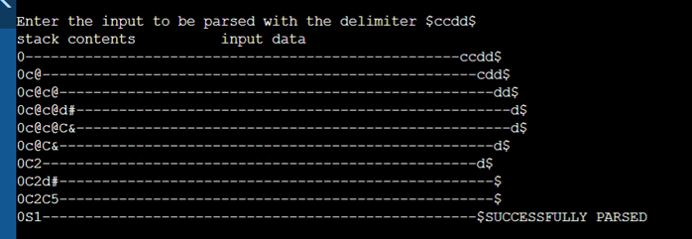

Viva Questions:

- Why bottom-up parsing is also called as shift reduce parsing?
- What are the different types of bottom up parsers?
- What is mean by LR (0) items?
- Write the general form of LR(1) item?
- What is YACC?
- What is LALR parsing?
- What is Shift reduced parser?
- What are the operations of Parser?
- What is the use of parsing table?
- What is bottom up parsing?

Additional Programs/Tasks:

- Problem Statement: Implement RECURSIVE DESCENT PARSER
AIM: To Implement the RECURSIVE DESCENT PARSER for the given grammar / language

ALGORITHM/ PROCEDURE:

Input : A string w$ , where w is a string of terminals
Output : w is accepted if it can be derived by the given grammar, else not accepted.

Step 1: Start
Step 2: declare w[10] as char and Z as an array
Step 3: enter the string with $ at the end
Step 4: if (A(w[z]) then increment z and check for (B(w[z])) and if satisfies increment z and check for ‘d’ if d is present then increment and check for (D(w[z]))
Step 5: if step 4 is satisfied then the string is accepted else string is not
Step 6: For the production S→cAd write the function S()
Step 7: For the production A→ab/a write the function A()
Step 8: if steps7,8,9 are satisfied accordingly string is accepted else string is not accepted
Step 9: Stop

SOURCE CODE:

#include<stdio.h>

char input[15];
int ip=0;
int S();
int A();
int S()
{
if(input[ip]=='c')
{
ip++;
if(A())
{
if(input[ip]=='d')
{
ip++;
return 1;
}
}
}
return 0;
}
int A()
{
int isave=ip;
if(input[ip]=='a')
{
ip++;
if(input[ip]=='b')
{
ip++;
return 1;
}
}
ip=isave;
if(input[ip]=='a')
{
ip++;
return 1;
}
else
return 0;
}

int main()
{
int flag;
printf("Enter the input of the grammar S->cAd, A->ab/a ending with $");
scanf("%s",input);
flag=S();
if(flag==1 && input[ip]=='$')
{
printf("valid input");
}
else
printf("invalid input");
return 0;
}
INPUT:
Enter the input of the grammar S->cAd, A->ab/a ending with $
cad$
OUTPUT:
valid input

- AIM: Design a Lexical Analyzer.
Theory:

The lexical analyzer is the first phase of a compiler. Its main task is to read the input characters and produce as output a sequence of tokens. Up on receiving a “get next token” command from the parser, the lexical analyzer reads input characters until it can identify the next token. Token is a group of characters having a collective meaning. Tokens are constants, identifier, keywords, operators, special symbols.

Program: 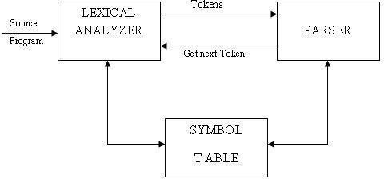

#include<stdio.h>
#include<conio.h>
#include<string.h>
#include<ctype.h>
void main()
{
int i,j; clrscr();
char keywords[10][10]={"BEGIN","IF","THEN","ELSE","END"};
char operators[10][10]={"<","<=",">","=","!="};
char string[10];
int ch,l,found=0;
printf("/n enter any data of your choice");
scanf("%s",string);
l=strlen(string);
for(i=0;i<l;i++)
string[i]=toupper(string[i]);
for(i=0;i<5;i++)
{
if(strcmp(&keywords[i][0],string)==0)
{
found=1;
ch=1;
break;
}
}
for(i=0;i<5;i++)
{
if(strcmp(&operators[i][0],string)==0)
{
found=1;
ch=2;
break;
}
}
switch(ch)
{
case 1: if(found==1)
printf("\n you have entered keyword"); break;
case 2: if(found==1)
printf("\n you have entered relational operator"); break;
default: printf("\n you have entered default choice");
}
getch();
}
Input:
enter any data of your choice else
Output:
you have entered keyword

VIVA QUESTIONS

- What is lexical analyzer?
- Which compiler is used for lexical analyzer? What is the output of Lexical analyzer?
- What is LEX source Program?
- What is token?
- What is lexeme?
- What is the difference between token and lexeme? Define phase and pass?
- What is the difference between phase and pass?
- What is the difference between compiler and interpreter?

- AIM: Write a LEX Program to check vowel or consonant

LEX SPECIFICATION PROGRAM / SOURCE CODE (vowel.l) :

// ********* LEX Tool program to check vowel or consonant *****************//

%{
#include<stdio.h>
#undef yywrap
#define yywrap() 1
%}

vowels [aeiouAEIOU]

letter [a-zA-Z]

%%

{vowels}* {printf("\n%s is a vowel!",yytext);}

{letter}* {printf("\n%s is a consonant!",yytext);}

%%

int main()

{

yylex();

}

INPUT 1:

a

OUTPUT:

a is a vowel!

INPUT 2:

z

OUTPUT:

z is a consonant!

- AIM: Write a LEX Program to check Operator.

LEX SPECIFICATION PROGRAM / SOURCE CODE (operator.l) :

// ********* LEX Tool program to check Operator *****************//

%{

#include<stdio.h>

%}

assg =

aop [+-/*%]

rop (>|<|">="|"<="|"=="|"!=")

bop [&^~|"|"]

lop (!|&&|"||")

shift ("<<"|">>")

inc ("++")

dec ("--")

other [a-zA-Z0-9_@#$.?;]

%%

{assg} {printf("\n%s is an Assignment operator!",yytext);}

{aop} {printf("\n%s is an Arithmetic operator !",yytext);}

{rop} {printf("\n%s is a Relational operator!",yytext);}

{bop} {printf("\n%s is a Bitwise operator!",yytext);}

{lop} {printf("\n%s is a Logical operator!",yytext);}

{shift} {printf("\n%s is a Shift operator!",yytext);}

{inc} {printf("\n%s is an Increment operator!",yytext);}

{dec} {printf("\n%s is a Decrement operator!",yytext);}

{other} {printf("\n%s is not an operator !",yytext);}

%%

int main()

{

yylex();

}
INPUT 1:

= =

OUTPUT:

= = is a relational operator

INPUT 2:

+

OUTPUT:

+ is a arithmetic operator

